# Data Collection and Processing

## Google Analytics data collection

**Website Data Collection**

* **Tracking Code:** JavaScript snippet included on every web page to track user interactions.
* **Cookies:** Used to track traffic on a website and its subdomains.
* **Cross-Domain Tracking:** Necessary for tracking users across different domains.

**Anatomy of a "Hit"**

* **Hit Definition:** A URL string with parameters containing user information.
* **Information in a Hit:**
  + User’s browser language
  + Page name
  + Screen resolution
  + Analytics ID
  + User identifier (randomly generated)
* **Types of Hits:**
  + **Pageview Hits:** Triggered when a page is loaded.
  + **Event Hits:** Track interactions like button clicks, passing parameters (action, category, label, value).
  + **Transaction Hits:** Track ecommerce data (purchases, transaction IDs, SKUs).
  + **Additional Hits:** Social hits, page timing hits.

**Data Enrichment**

* **Sources of Additional Data:** IP address, server-log files, ad-serving data.
* **Additional Information:**
  + User’s location
  + Browser and OS specifics
  + User’s age and gender
  + Source/medium of referral

**Reporting**

* **Dimensions:** Ways to categorize metric data (e.g., country, device type).
* **Processing:** Hits are combined with additional data for processing by Analytics servers.

### ****Domains and Directories****

#### ****Analytics Cookies and Domains****

* **Document.domain Property:**
  + Analytics sets and reads cookies based on the **document.domain** property.
  + Subdomains (e.g., dogtoys.example.com) are distinct from primary domains (e.g., [www.example.com](http://www.example.com/)).
* **Using Debugging Tools:**
  + Tools like Firebug can help determine the domain of a website by checking the **document. domain** property.

#### ****Separate Domains and User Data****

* **Separate User and Traffic Data:**
  + Each domain's cookies store user information (session counts) and traffic sources (referrals, searches, ad campaigns) separately.
  + Sessions and users are counted independently across different domains.
* **Cross-Domain Tracking:**
  + Customizations are needed to link user and referral traffic between different domains.

#### ****Content Tracking Across Domains****

* **Web Property ID:**
  + Content for different domains is tracked using the same web property ID.
  + Content data for all domains can appear in the same reporting view if the same tracking code is used.
* **Include Filters:**
  + Use Include filters to ensure only content for your domain is tracked.

#### ****Sub-Directories and Shared Cookies****

* **Standard Setup:**
  + User, traffic, and content data are shared across the entire website and its sub-directories.
* **Restricting Tracking:**
  + To track a sub-directory independently, set the path of the cookie to the sub-directory.

### ****Data Limits for Universal Analytics Properties****

#### ****2.1 Data Collection Limit****

* **Hit Definition:**
  + Each user interaction (pageview, screen view, event, transaction) can be a hit.
* **Monthly Hit Limit:**
  + Exceeding the hit limit per month may result in unprocessed excess hits and limited report access.
* **Options for Handling Hit Limits:**
  + **Upgrade to Google Analytics 360:** Paid service with higher hit volume support.
  + **Send Fewer Hits:** Use sampling rates or remove extra tracking calls.
  + **Upgrade to Google Analytics 4:** Free analytics solution with unlimited reporting for up to 500 distinct events.

#### ****2.2 Data Processing Latency****

* **Latency Period:**
  + Standard accounts: 24-48 hours.
  + Accounts with >200,000 sessions/day: Reports refreshed once a day.
* **Analytics 360:**
  + Higher limit of 2 billion hits/month and faster data processing.

### ****Check Your Tag Setup****

#### ****3.1 Real-Time Reports****

* **Purpose:**
  + Verify if Google Analytics tags are working by checking current site activity.
* **Steps to Access:**
  + Sign in to Analytics, navigate to the relevant view, open Reporting, and select Real-Time > Overview.

#### ****3.2 Google Tag Assistant****

* **Function:**
  + Chrome extension that verifies if Analytics tags are firing correctly.
* **Usage:**
  + Record user journeys and check for errors in hit transmission.
* **Installation and Use:**
  + Install Google Tag Assistant, record a user journey, and review the report for errors.

## Categorizing into users and sessions

**1. Differentiating New vs. Returning Users**

* **User Identification:**
  + Google Analytics assigns a unique ID to each user via browser cookies.
  + New ID = New User; Existing ID = Returning User.
* **Limitations:**
  + Cookie clearing or blocking resets user ID, counting users as new.
  + Users on different devices are counted as separate unless User ID feature is enabled.

**2. Defining Sessions**

* **Session Definition:**
  + Begins when a user navigates to a page with tracking code (generates a pageview hit).
  + Ends after 30 minutes of inactivity (default setting).
* **Examples of Session Hits:**
  + **Example 1:** User visits a page and leaves immediately – one pageview hit in a single session.
  + **Example 2:** User visits a page and clicks a tracked video – a pageview hit and an event hit in one session.
  + **Example 3:** User visits a page, switches to another tab for over 30 minutes, then returns – two separate sessions, one with a pageview hit, one with an event hit.
* **Session Timeout:**
  + Default is 30 minutes; can be adjusted to better align with user behavior (e.g., extend for video watching).

**3. Joining Data from External Sources**

* **Measurement Protocol:**
  + Allows sending data from any web-connected device (e.g., POS systems, kiosks) to Google Analytics.
  + Requires manual construction and sending of hits via a URL string.
* **Linking with Other Google Tools:**
  + Integrate data from Google Ads, AdSense, Google Search Console, etc.
  + Allows viewing clicks, impressions, and cost data in Google Analytics.

### How a Web Session is Defined in Universal Analytics

**Overview**

* **Definition:** A session is a group of user interactions within a given time frame (e.g., page views, events, transactions).
* **Multiple Sessions:** A single user can open multiple sessions on the same or different days.

**Time-Based Expiration**

* **Default Duration:** Sessions last until 30 minutes of inactivity or at midnight.
* **Adjustable Duration:** Can be set from a few seconds to several hours.
* **Example:** If a user returns within 30 minutes, the session continues; if after 30 minutes, a new session starts.

**Campaign-Based Expiration**

* **New Session Trigger:** A new session begins if a user returns via a different campaign.
* **Campaign Source Change:** Happens with new search engine visits, referring sites, or campaign-tagged URLs.
* **Example:** Switching from a Google organic search to a Google Ads click starts a new session.

### Session and Campaign Timeout Handling

**Session Timeout**

* **Default Setting:** 30 minutes of inactivity.
* **Adjustment:** Can be modified in the admin settings to match user behavior (e.g., longer for content-heavy sites).

**Campaign Timeout**

* **Default Setting:** 6 months.
* **Adjustment:** Can be set to match the duration of the campaign (up to 2 years).

**Settings Adjustment Steps:**

1. Navigate to the property in the Admin menu.
2. Select Tracking Info > Session Settings.
3. Adjust session and campaign timeout settings.

### Linking/Unlinking Google Ads and Analytics

**Benefits of Linking:**

* **Comprehensive Data:** View full customer journey from ad interaction to goal completion.
* **Enhanced Reporting:** Import Analytics goals and Ecommerce data into Google Ads.
* **Remarketing:** Use Analytics data for more precise Google Ads remarketing.

**Limits:**

* **Maximum Link Groups:** 400 per Analytics property.
* **Maximum Google Ads Accounts:** 1,000 per link group.
* **Eligibility:** Only active Google Ads accounts can be linked.

**Linking Steps:**

1. Sign in to Google Analytics.
2. Navigate to Admin > Product Links > Google Ads Links.
3. Click + New link group and select the Google Ads accounts.
4. Enable auto-tagging or configure manual tagging.
5. Click Link accounts.

**Unlinking Steps:**

1. Sign in to Google Analytics.
2. Navigate to Admin > Product Links > Google Ads Links.
3. Select the link group and click Delete link group.

### About Google Ads in Analytics

**Integration:**

* **Link Accounts:** Use the same email address for both Google Ads and Analytics.
* **Setup:**
  1. Sign in to Analytics.
  2. Navigate to Admin > Product Links > Google Ads Links.

**Data Discrepancies:**

* **Causes:**
  + Iframes: Browsers that don’t support iframes.
  + Blocking Software: Ad blockers, firewalls.
  + Timezone Differences: Different timezones in Analytics and Google Ads accounts.
  + View Filters: Filters in Analytics views can exclude certain data.

### About Search Console

**Reports:**

* **Performance Data:** Includes user queries, impressions, clicks, CTR, and site engagement metrics (bounce rate, conversion rate).
* **Integration Steps:**
  1. Verify your site with Search Console.
  2. Configure SEO reporting in Analytics.
  3. Access reports via Acquisition > Search Console in Analytics.

**Dimensions and Metrics:**

* **Dimensions:** Query, Landing Page, Country, Device.
* **Metrics:**
  + **Acquisition:** Impressions, Clicks, CTR, Average Position.
  + **Behavior:** Bounce Rate, Pages/Session.
  + **Conversions:** Ecommerce Conversion Rate, Transactions, Revenue.

## Applying configuration settings

**Data Configuration Rules:**

* **Purpose:** To define how data is processed and analysed in reports.
* **Features:** Includes data filters, goals, data grouping, Custom Dimensions, Custom Metrics, and imported data.

**Data Filters:**

* **Function:** Exclude, include, or modify data during processing.
* **Usage:** Align data with business needs (e.g., exclude internal traffic, include data from a specific country).
* **Implementation:** Apply filters based on specific measurement objectives.

**Goals:**

* **Types:**
  + **Destination Goals:** Triggered when a user views a specific page.
  + **Event Goals:** Triggered by specific actions defined as events.
  + **Duration Goals:** Based on session length.
  + **Pages/Screens per Session Goals:** Based on the number of pages viewed in a session.
* **Conversions:** Counted once per session per goal.
* **Processing:** Analytics calculates goal completions, goal value, and goal conversion rate.

**Channel and Content Groupings:**

* **Channel Groupings:** Organize data into customized channels.
* **Content Grouping:** Aggregate metrics within reports based on website structure.

**Custom Dimensions and Metrics:**

* **Custom Dimensions:** User-defined dimensions specific to business needs, applicable as secondary dimensions, primary dimensions in Custom Reports, or segments.
* **Custom Metrics:** Collected for any dimension that can't be measured by predefined metrics.
* **Usage:** Can be integrated with offline data tools (e.g., CRM systems) into Analytics.

**Data Import:**

* **Purpose:** Combine offline data with Analytics hit data for comprehensive insights.
* **Application:** Enhance reports with business-specific data.

**Key Points:**

* **Pre-Processing Setup:** Configuration rules must be set up before data processing.
* **Irreversibility:** Configuration settings cannot be applied retroactively to processed data.

### View Filters

**Purpose:**

* **Modify Data:** Filters limit or modify data in a view (e.g., exclude traffic from specific IP addresses, include data from subdomains, convert URLs to readable text).

**Predefined Filters:**

* **Exclude/Include Traffic from ISP Domain:** Specify domain name without host server label (e.g., example.com).
* **Exclude/Include Traffic from IP Addresses:** Use simple ranges or custom filters with regular expressions.
* **Exclude/Include Traffic to Subdirectories:** Filter traffic to specific subdirectories (e.g., /motorcycles).
* **Exclude/Include Traffic to Hostname:** Filter traffic to specific hostnames (e.g., sales.example.com).

**Custom Filters:**

* **Exclude:** Excludes hits matching the filter pattern.
* **Include:** Includes hits matching the filter pattern.
* **Lowercase/Uppercase:** Converts field content to all lowercase or uppercase.
* **Search & Replace:** Searches for a pattern and replaces it with an alternate form.
* **Advanced:** Builds a field from one or two other fields using expressions.

**Common Uses:**

* **Exclude Internal Traffic:** Identify and exclude company IP addresses.
* **Report on Specific Directories:** Use Include filters for specific directories.
* **Track Subdomains Separately:** Create separate views for each subdomain with Include filters.

**Limitations:**

* **Destructive:** Filters permanently alter data in the view.
* **Delay:** Filters require up to 24 hours to apply.
* **Field Existence:** Fields must exist in the hit for filters to apply.
* **Account-Level:** Changes to filters affect all views using them.
* **Processing Order:** Filters are applied after data processing.

### Goals

**Purpose:**

* **Measure Objectives:** Goals measure how well a site or app fulfils target objectives (e.g., purchases, form submissions).

**Goal Types:**

* **Destination:** Triggered when a specific page loads.
* **Duration:** Based on session length.
* **Pages/Screens per Session:** Based on the number of pages/screens viewed.
* **Event:** Triggered by specific actions defined as events.
* **Smart Goals:** Evaluates visits and translates the best ones into Smart Goals.

**Funnels for Destination Goals:**

* **Path Specification:** Record where users enter and exit the path towards a goal.

**Goal Value:**

* **Monetary Value:** Assigns a monetary amount to conversions.

**Goal ID and Sets:**

* **Numeric ID:** Goals are assigned an ID from 1 to 20.
* **Goal Sets:** Categorize goals into sets of up to 5.

**Reporting:**

* **Conversion Rates:** Analyze goal completion and conversion rates in various reports.

**Limits:**

* **20 Goals per View:** To track more, create additional views or edit existing goals.
* **Non-Retroactive:** Goals apply only to data collected after goal creation.

**Best Practices:**

* **Intuitive Naming:** Use descriptive names for goals.
* **Assign Values:** Use monetary or numeric values to evaluate conversions.

### Channel Groupings

**Purpose:**

* **Classify Traffic:** Rule-based groupings of traffic sources for organized data analysis.

**Default Channel Grouping:**

* **Common Sources:** Includes channels like Paid Search and Direct.

**Custom Channel Groupings:**

* **User-Level:** Visible only to the creator, used for customized traffic classification.
* **View-Level:** Visible to all users with access to the view, affecting how traffic is labelled in new sessions.

**Editing Default Channel Grouping:**

* **Permanent Changes:** Alters how incoming traffic is classified but is not retroactive.

**Multi-Channel Funnels:**

* **Assisted Conversions:** Use Default MCF Channel Grouping to analyze conversion paths.

**Limits and Caveats:**

* **Filter Interaction:** Groupings follow dimension values altered by view filters.
* **Cost Data:** Some dimensions may not allow cost data queries.

### Content Grouping

**Purpose:**

* **Logical Structure:** Group content into a structure for aggregated metric analysis.

**Creation:**

* **Content Groups:** Define groups for categories like Men, Women, and Children.
* **Assignment Methods:**
  + **Tracking Code:** Modify tracking code to assign content.
  + **Extraction:** Use regular expressions to identify content.
  + **Rule Definitions:** Use rules to identify content.

**Usage:**

* **Reports:** Compare aggregated statistics and drill down to individual URLs.

**Limitations:**

* **Non-Retroactive:** Valid only from the creation date forward.

### Custom Dimensions & Metrics

**Purpose:**

* **Non-Standard Data:** Include custom data in reports.

**Configuration:**

* **Indices:** Up to 20 custom dimensions and metrics per property (200 for 360 accounts).
* **Definition:** Specify name, scope, and activation status.

**Collection:**

* **Data Pairing:** Custom dimensions and metrics are sent with other hits.

**Processing:**

* **Scope:** Determines the hits to which a value is applied (product, hit, session, user).
* **View Filters:** Filters may affect custom dimension and metric values.

**Reporting:**

* **Custom Reports:** Available in custom reports and as secondary dimensions in standard reports.

**Examples:**

* **Hit-Level Scope:** Track difficulty of game levels.
* **Session-Level Scope:** Group screen views by the day of a trial.
* **User-Level Scope:** Differentiate between free and paid users.
* **Product-Level Scope:** Track product attributes like powerup strength.

**Implementation Considerations:**

* **Editing:** Changes to name or scope can affect data.
* **Planning:** Choose scope based on expected value changes.

## Storing data and generating reports

Data Processing:

* Transformation: Data is transformed into dimensions (e.g., location, device type) and metrics.
* Storage: Dimensions are stored in aggregate database tables for fast retrieval.

Reports Structure:

* Single Dimension: All reports feature a single dimension and corresponding metrics.
* Rows and Columns: Dimensions are shown in rows and metrics in columns.

Metrics Calculation:

* Time on Page: Calculated by subtracting the timestamp of a pageview hit from the next pageview hit.
* Pages per Session: Average number of unique pageview hits per session.
* Average Session Duration: Average time from the first to the last hit before the user leaves or the session times out.
* Bounce Rate: Calculated for users with only one interaction, assigning a session duration and Time on Page of zero.

Scope of Dimensions and Metrics:

* Scopes:
  + Hit-Level: Data for a single hit.
  + Session-Level: Data across an entire session.
  + User-Level: Data across individual users.
* Pairing: Metrics and dimensions can only be paired if they share the same scope.

Aggregation and Reporting:

* Property ID: Raw data is linked with the unique property ID for your account.
* Aggregate Tables: Data is added to aggregate tables processed daily for quick report display.
* Custom Reports: Analytics uses aggregate tables if available; otherwise, it processes raw data to generate reports.
* Sampling: Standard users experience session sampling at the property level; Analytics 360 users have sampling at the view level.

Data Handling:

* Irreversibility: Data processed with filters cannot be changed or recovered.
* API Access: Data can be accessed and analyzed using the Google Analytics Core Reporting API for building custom tools or integrating with third-party tools.

## Creating a measurement plan

**Overview:** A measurement plan guides the data collection in Analytics and helps set up relevant features. It aligns your business objectives with Google Analytics configuration settings.

**Steps to Create a Measurement Plan:**

1. **Define Business Objectives:**
   * Identify the main goals of your business.
   * Determine how you expect to measure these outcomes.
2. **Identify Key Actions (Conversions):**
   * **Macro Conversions:** Major actions fulfilling business objectives (e.g., making a purchase).
   * **Micro Conversions:** Smaller actions leading towards macro conversions (e.g., signing up for a newsletter).
3. **Examples of Conversions by Business Type:**
   * **E-commerce Site:**
     + Macro: Purchase a product.
     + Micro: Subscribe to a newsletter.
   * **Lead Generation Site:**
     + Macro: Fill out a contact form.
     + Micro: Follow the site on social media.
   * **Content Publisher:**
     + Macro: Engage with a significant amount of content.
     + Micro: Click into an article.
   * **Online Support Site:**
     + Macro: Complete a guided support flow.
     + Micro: Rate a support article.
4. **Develop a Measurement Plan:**
   * **Overall Business Objective:** The primary goal of your business.
   * **Strategies:** Support the overall objective.
   * **Tactics:** Specific actions to achieve strategies.
   * **Key Performance Indicators (KPIs):** Metrics to measure macro- and micro-conversions.
5. **Implement the Measurement Plan:**
   * Use the plan to set up Google Analytics.
   * Collect metrics that align with your business objectives and KPIs.

**Importance of a Measurement Plan:**

* It helps document the data most important to your business.
* Ensures that Google Analytics is configured to collect relevant data for measuring performance against business objectives.

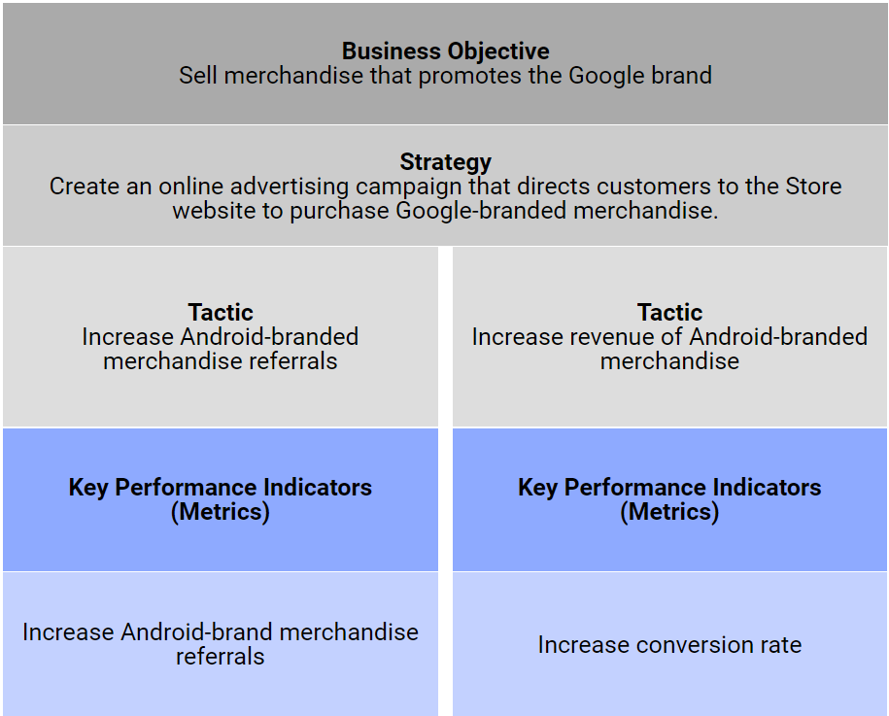

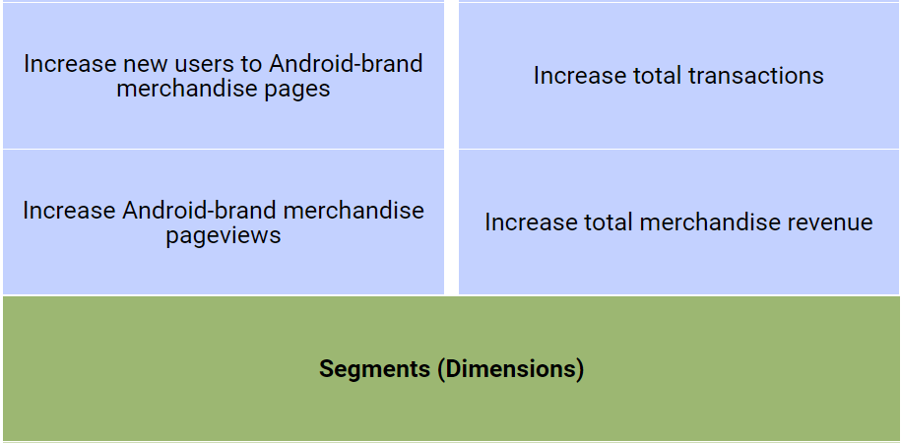

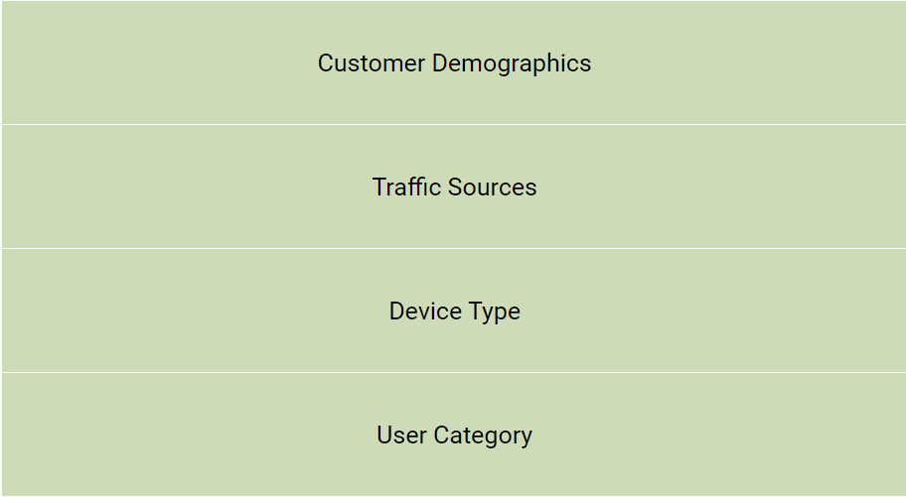

# Setting Up Data Collection and Configuration

## Organize your Analytics account

**Accounts**:

* Basic Setup: Typically, one Organization (optional), one account, and one property with three views: Raw Data, Test, and Master.
* Complex Setup: Agencies managing multiple companies can have different Organizations for each company, with separate Analytics accounts under each Organization.
* Account ID: Each account has a unique ID found in the Analytics tracking code to direct data correctly.

**Properties:**

* Multiple Properties: Set up multiple properties under one account to reflect business organization (e.g., separate properties for a website and a mobile app).
* Cross-Domain Tracking: For related websites with different URLs or subdomains, use cross-domain tracking to recognize user navigation between sites in the same session.
* Rollup Reporting (Analytics 360): Aggregate data from multiple properties into a new combined property. Note that imported or linked data from other accounts needs re-linking in the rollup property.
* Property ID: Each property has a unique Property ID appended to the Analytics ID to associate hits with the property.

**User Permissions:**

* Limits: Each account has a limited number of properties, and each property has a limited number of views.
* Access Control: Create views using filters for different departments and grant access to each view to the respective members.

**Example Setup:**

* Google Merchandise Store: Uses a single account, single property, and three views for raw data, testing, and production.

**Navigation:**

* Account Selector: Switch between different Organizations or Accounts using the account selector without signing in separately.
* Property Pulldown Menu: Switch properties in the Admin area.
* View Selector Menu: Navigate to different views in the admin section.

### Cross-Domain Measurement

**Standard Analytics Tag Behavior:**

* Records traffic to a given URL as a group.
* Tracks navigation paths, total time on site, number of sessions, unique sessions, and users.
* Treats traffic to separate URLs as unique and unrelated unless set up for cross-domain measurement.

**Cross-Domain Measurement:**

* Allows Analytics to see sessions on two related sites (e.g., an ecommerce site and a separate shopping cart site) as a single session.
* Recognizes users moving between related websites within the same session.
* Requires modification of Analytics tracking code on every page of every site you want to track.

### Roll-Up Reporting (Analytics 360 Only)

**Overview:**

* Aggregates data from multiple Analytics properties into combined reports.
* Allows global performance metrics and country-specific comparisons for multiple properties.

**Types of Properties:**

* **Source Properties:** Individual Analytics properties with data from a single site, app, or device.
* **Roll-Up Properties:** Aggregators of data from multiple Source Properties.

**Data:**

* Includes data from web, app properties, and data uploaded via the Measurement Protocol.
* Does not include data imported or linked from other accounts.
* Real-Time data from Source Properties is included.
* Cannot send data directly to Roll-Up Properties.

**Session Merging:**

* Sessions are merged if users are identified by the same Client-ID or User-ID across different Source Properties.
* Session timeout settings affect session merging.

**Requirements:**

* Roll-Up Property and all Source Properties must belong to the same Analytics 360 account.
* Service level for each Source Property must be set to 360.

**Creation and Management:**

* Creation handled by Google Analytics 360 Support team.
* Manage Source Properties in Analytics Admin under Property > Roll-Up Management.

**System and Data Limits:**

* Each Roll-Up Property can have a maximum of 200 Source Properties.
* Each hit processed by a Roll-Up Property counts as 0.5 of a hit toward the monthly billable hit volume.

**Additional Considerations:**

* Temporary data anomalies can occur with direct sessions.
* Multi-Currency Support can affect data if implemented.
* Remarketing Audiences can be created based on Roll-Up Properties.

### Working with Multiple Trackers

**Purpose:**

* Allows sending data to multiple properties from a single page.
* Useful for sites with multiple owners overseeing different sections.

**Setup:**

* Create separate trackers, with at least one named tracker.
* Example commands to create trackers:

ga('create', 'UA-XXXXX-Y', 'auto');

ga('create', 'UA-XXXXX-Z', 'auto', 'clientTracker');

**Running Commands for Specific Trackers:**

* Prefix command names with the tracker name followed by a dot.
* Example commands to send pageviews:

ga('send', 'pageview');

ga('clientTracker.send', 'pageview');

### Account Structures

**Overview:**

* Google Analytics accounts can track single or multiple properties and have various views for different purposes.

**Accounts and Properties:**

* An account can have multiple properties, each with a unique property ID.
* Properties are linked to views within an account.

**Views:**

* Views determine which data from a property appears in reports.
* Master views should have no filters and contain all historical data.
* Filtered views can include/exclude specific data for detailed analysis.

**Example Scenarios:**

1. **Personal Account:**
   * My Blog (example.blogspot.com) with property ID UA-18988-2.
   * My Webs ite ([www.example.com](http://www.example.com)) with property ID UA-18988-1.
   * My Gadget (84632.gmodules.com) with property ID UA-18988-3.
2. **Team Account:**
   * Master View (googleanalytics.com) with property ID UA-10876-1.
   * Sales View (googleanalytics.com/sales) with the same property ID and specific filters.
   * Marketing View (googleanalytics.com/marketing) with the same property ID and specific filters.

**Sharing Reports:**

* Share reports with users who have Google Accounts.
* Control access to specific accounts, properties, and views.

## Set up advanced filters on views

**Overview:** Filters refine your data for better readability in reports. They can track specific website directories or subdomains in separate views.

**Types of Filters:**

1. **Predefined Filters:**
   * Already created filters in Google Analytics.
   * Include or exclude data based on traffic from ISP domain, IP addresses, subdirectories, or hostname.
2. **Custom Filters:**
   * Include or exclude hits, format data, search, and replace data collected in the hit.
   * Match specific filter text-patterns.

**Common Custom Filters:**

* **Include Filters:**
  + Analyze specific traffic, e.g., mobile traffic by setting a filter for Device Category with the value “Mobile.”
  + Track specific campaign data by including only campaign data with the specified campaign name or type parameter.
* **Exclude Filters:**
  + Exclude specific traffic, e.g., Paid Search (CPC) traffic.
* **Lowercase/Uppercase Filters:**
  + Normalize data by converting all data to lowercase or uppercase, eliminating duplicates.

**Advanced Filters:**

* Use regular expressions (regex) to remove, replace, and combine filter fields.
* Examples:
  + Track variations of keywords, e.g., “Android plush doll” or “Android stuffed doll.”
  + Filter out technical query parameters from URLs to avoid duplicate page reports.
  + Add hostname to distinguish between multiple domains.

**Implementation Tips:**

* **Order of Filters:**
  + The order of filters is crucial as each filter passes filtered data to the next.
  + Adjust order in “Admin” under “Filters” and select “Assign Filter Order.”
* **Testing Filters:**
  + Always test filters in a “test” view before applying them to the “master” view.
  + Use real-time reports to ensure filters are working as expected.

**Key Points:**

* Filters are not retroactive; they apply from the moment you create them.
* Filters can take up to 24 hours to be applied to your data.
* Be cautious when using filters across multiple views, as changes will apply to all views.

### View Filters in Google Analytics

**Overview:** Filters in Google Analytics are used to refine or modify data in a view. They can exclude traffic from specific IP addresses, include data from certain subdomains, or convert URLs to readable text. Editor role at the account level is required to manage filters.

### ****Types of Filters:****

1. **Predefined Filters:**
   * **Exclude/Include Traffic from ISP Domain:** Filter traffic based on specific domains.
   * **Exclude/Include Traffic from IP Addresses:** Filter clicks from certain IP addresses.
   * **Exclude/Include Traffic to Subdirectories:** Filter traffic to specific subdirectories.
   * **Exclude/Include Traffic to Hostname:** Filter traffic to specific hostnames.
2. **Custom Filters:**
   * **Exclude:** Excludes hits that match the filter pattern.
   * **Include:** Includes hits that match the filter pattern.
   * **Lowercase/Uppercase:** Converts data to all lowercase or uppercase.
   * **Search & Replace:** Searches for a pattern and replaces it with an alternative.
   * **Advanced:** Builds fields from one or two other fields using regular expressions.

### ****Common Uses for Filters:****

* **Exclude Internal Traffic:** Set up a filter to exclude traffic from specific IP addresses.
* **Report on Specific Directories:** Use an Include filter for a particular directory.
* **Track Subdomains Separately:** Create separate views for each subdomain and use Include filters.

### ****Limitations of Filters:****

* Filters are **destructive**; they permanently alter incoming hits in a view.
* Filters require up to **24 hours** to be applied to data.
* Filters act on fields that **must exist** in the hit.
* Filters are **account-level** objects; changes affect all views using the filter.
* Filters are applied **after data processing**.
* Filters do not apply to **product-scoped dimensions** from data imports.

### ****Advanced Filters:****

* Use POSIX regular expressions to construct fields from existing fields.
* **Wildcards:** ., *, +, ?, (), [], -, |, ^, $, \.
* **Controls:**
  + **Override Output Field:** Decide what to do if the output field already exists.
  + **Field Required:** Determine action if an expression does not match.
  + **Case Sensitive:** Specify if data must match the exact capitalization.

### ****Regular Expressions (Regex):****

* **Metacharacters:**
  + **.** Match any single character.
  + **+** Match one or more of the previous item.
  + **|** Create an OR match.
  + **^** Match the beginning of the field.
  + **$** Match the end of the field.
  + ** Escape metacharacters.
* **Default Behavior:**
  + **Universal Analytics:** Partial match by default.
  + **Google Analytics 4:** Full match by default; use metacharacters for partial match.
* **Tips:**
  + Use simple expressions for clarity.
  + Match metacharacters with backslashes.
  + Construct regex to limit matches appropriately.

### ****Custom Filter Fields:****

* **Content and Traffic:**
  + Request URL, Hostname, Page Title, Referral, Campaign Target URL, Hit Type, Search Term, Site Search Category.
* **Campaign or Ad Group:**
  + Campaign Source, Medium, Name, AdGroup, Term, Content, Code, Referral Path.
* **Ecommerce:**
  + Transaction Country, Region, City, Store/Order Location, Item Name, Code, Variation, Transaction ID, Currency Code.
* **Audience/Users:**
  + Browser, Browser Version, Operating System Platform, Language Settings, Screen Resolution, IP Address, User Type, ISP Organization.
* **Location:**
  + Country, Region, City.
* **Event:**
  + Event Category, Action, Label.
* **Application:**
  + Application ID, Installer ID, Name, Version, Screen Label, Exception Description.
* **Mobile Device:**
  + Mobile Brand Name, Model Name, Marketing Name, Pointing Method.
* **Social:**
  + Social Network, Action, Target.
* **Custom Dimensions:**
  + User-defined custom dimensions for specific tracking.

## Create Your own Custom Dimensions

**Overview:** Custom Dimensions in Google Analytics allow you to collect and report data tailored to your business needs. They capture specific characteristics or behaviors of users, which can be used for more detailed analysis and reporting.

**Steps to Set Up Custom Dimensions:**

1. **Define Custom Dimensions:**
   * **Go to Admin:** Select the Property where you want to apply the Custom Dimension.
   * **Navigate to Custom Definitions:** Click on “Custom Definitions” and then “Custom Dimension.”
   * **Create New Dimension:** Click “New Custom Dimension,” name it, and define its scope.
2. **Scope Levels:**
   * **Hit-Level:** Tracks data for individual interactions (e.g., page views).
   * **Product-Level:** Groups data associated with a specific product.
   * **Session-Level:** Organizes data for the duration of a session.
   * **User-Level:** Categorizes data for individual users.
3. **Activate and Save:**
   * **Set Active:** Ensure the Custom Dimension is active (default).
   * **Save:** Click “Create” to save the dimension.
4. **Implement JavaScript Code:**
   * **Copy Tracking Code:** After creating the dimension, you'll receive JavaScript code.
   * **Integrate Code:** Implement this code on your website to capture custom data. Use tools like Google Tag Manager to simplify the process.

**Example Usage:** The Google Merchandise Store uses a Custom Dimension to identify if users are employees or retail customers by tracking whether they come from an employee discount link. The JavaScript code on the site captures and passes this data to Google Analytics.

**Using Custom Dimensions in Reports:**

* **Standard Reports:** Use Custom Dimensions as secondary dimensions.
* **Custom Reports:** Use them as primary dimensions for detailed analysis.
* **Example:** In the Product Performance report, adding a secondary dimension like “User Category” helps compare the popularity of products among different user types.

**Limitations:**

* **Not Retroactive:** Custom Dimensions only apply to data collected after their creation.
* **Limit:** Standard users can create up to 20 Custom Dimensions; Analytics 360 users can create up to 200.

**Summary:** Custom Dimensions enhance your ability to collect and analyze data specific to your business needs, allowing for more targeted insights and reporting in Google Analytics. Follow the setup process, define appropriate scopes, implement the necessary JavaScript, and utilize these dimensions effectively in your reports for better data-driven decisions.

### Setting Up Custom Dimensions and Metrics in Universal Analytics

**Overview:** Custom dimensions and metrics in Universal Analytics enable you to collect and analyze non-standard data, complementing the default dimensions and metrics. They allow for the integration of external data like CRM information with Google Analytics data.

**Lifecycle of Custom Dimensions and Metrics:**

1. **Configuration:** Define custom dimensions/metrics with an index, name, and scope.
2. **Collection:** Send values to Analytics as a pair of index and value parameters.
3. **Processing:** Apply scope and filters to collected data.
4. **Reporting:** Use custom dimensions/metrics in reports.

**Configuration Steps:**

1. **Create Custom Dimensions/Metrics:**
   * **Navigate to Admin:** Select Property > Custom Definitions > Custom Dimensions/Metrics.
   * **Create New:** Click “+New Custom Dimension” or “+New Custom Metric.”
   * **Define Settings:**
     + **Custom Dimension:** Set Name, Scope (hit, product, session, user), and ensure it's Active.
     + **Custom Metric:** Set Name, Type (Integer, Time, Currency), and specify Minimum/Maximum values.
2. **Record Index Number:** Note the index number assigned by Google Analytics.

**Collection:**

1. **JavaScript Implementation:**
   * **Set Value:** Use ga('set', 'cd[index]', 'value') for dimensions or ga('set', 'metric[index]', value) for metrics.
   * **Send Hit:** Ensure the custom dimension/metric is sent with a hit (pageview, event, transaction).

**Example Implementation:**

JavaScript

// Custom Dimension Example

ga('create', 'UA-XXXX-Y', 'auto');

ga('set', 'cd1', 'Level 1');

ga('send', 'pageview');

// Custom Metric Example

ga('create', 'UA-XXXX-Y', 'auto');

ga('set', 'metric1', 1);

ga('send', 'event', 'Level', 'completion');

**Scopes:**

1. **Hit-Level Scope:** Applies to individual hits. Example: Track page difficulty.
2. **Session-Level Scope:** Applies to all hits in a session. Example: Track the day of a free trial.
3. **User-Level Scope:** Applies to all hits across current and future sessions for a user. Example: Track whether a user is on a free trial or paid version.
4. **Product-Level Scope:** Applies to specific products. Example: Track powerup strength in a game.

**Reporting:**

* **Custom Reports:** Use custom dimensions/metrics in custom reports for detailed analysis.
* **Standard Reports:** Custom dimensions can be secondary dimensions.
* **Limitations:** They are not retroactive and apply only to data collected after setup.

**Common Use Cases:**

1. **Integrate CRM Data:** Merge Analytics with CRM data to track metrics like user gender.
2. **Game Development Metrics:** Track custom game metrics such as level completions or powerup strengths.
3. **Ecommerce Custom Tracking:** Use product-level dimensions and metrics to track specific product attributes or sales performance.

**Limits and Caveats:**

* **Indices Limit:** 20 per property for standard accounts, 200 for Analytics 360.
* **Non-Editable:** Once set, they can't be deleted but can be disabled.
* **Scope Changes:** Avoid editing scope as it affects data consistency.
* **Incompatibilities:** Some custom dimensions might not be compatible with demographic data.

### Implementation Considerations:

1. **Plan Scope:** Choose the correct scope based on how often the value changes (hit for frequent changes, user for less frequent).
2. **Avoid Reuse:** Do not reuse indices for different purposes as it conflates data.

### Setting Custom Dimensions and Metrics via Tag Manager:

**Using a Page Variable:**

1. **Create Custom Dimension:**
   * Follow the steps in Admin to define a custom dimension.
2. **Set Up Tag Manager Variable:**
   * Create a new variable in Tag Manager to capture the value from the page.
3. **Enable Custom Dimensions in Tags:**
   * Add the custom dimension in the Google Analytics Settings variable in Tag Manager.

**Example:**

JavaScript

var dimensionValue = 'SOME_DIMENSION_VALUE';

ga('set', 'dimension6', dimensionValue);

**Using Data Layer:**

1. **Create Custom Dimension:**
   * Define in Admin as per normal.
2. **Create Data Layer Variable:**
   * Set up in Tag Manager to capture specific data layer values.
3. **Enable in Tags:**
   * Add the custom dimension in the Google Analytics Settings variable using the data layer variable.

**Example:**

JavaScript

<button onclick="dataLayer.push({'destination': 'paris'});">Book this trip to Paris!</button>

### Summary:

Custom dimensions and metrics expand the functionality of Google Analytics by allowing for the integration of specific, non-standard data into your reports. Proper setup involves defining, collecting, processing, and reporting custom data, with considerations for scope and implementation methods using tools like Google Tag Manager.

## Create your own Custom Metrics

**Overview:** Custom Metrics allow you to track business-specific data in Google Analytics that is not available through default metrics. These can measure anything from the number of ads loaded on a page to bandwidth usage, or even specific product pageviews.

**Steps to Set Up Custom Metrics:**

1. **Access Admin Settings:**
   * Navigate to **Admin** in your Google Analytics account.
   * Select the **Property** where you want the custom metric to be applied.
   * Go to **Custom Definitions** > **Custom Metrics**.
   * Click **New Custom Metric**.
2. **Configure Custom Metric:**
   * **Name:** Provide a descriptive name for the metric.
   * **Scope:** Choose between “hit” or “product” scope.
     + **Hit:** Increment with each hit sent by the tracking code.
     + **Product:** Increment based on the value assigned to the product.
   * **Format Type:** Select the format: Integer, Decimal, or Time-based value.
     + **Integer:** Useful for counting occurrences (e.g., pageviews).
     + **Decimal:** For more precise measurements (e.g., monetary values).
     + **Time-based:** For metrics involving time (e.g., load times).
   * **Minimum/Maximum Values:** Set limits to avoid processing incorrect data.
     + **Example:** Min value 0, Max value 2.
   * **Active Status:** Ensure the metric is active to collect data.
3. **Implement Tracking Code:**
   * **Copy JavaScript Code:** Provided upon creation.
   * **Add to Web Pages:** Insert the tracking code on relevant pages to collect metric data with hits.

**Example Implementation:**

JavaScript

ga('create', 'UA-XXXX-Y', 'auto');

// Set value for custom metric at index 1.

ga('set', 'metric1', 1);

// Send the custom metric value with a pageview hit.

ga('send', 'pageview');

**Overview and Management:**

* **Review Metrics:** View all Custom Metrics in the overview screen under Custom Definitions.
* **Index Assignment:** Metrics are assigned index numbers in order of creation and cannot be chosen manually.

**Best Practices for Custom Metrics:**

* **Plan Reporting Needs:** Determine how metrics should appear and interact in reports.
* **Design Collection Carefully:** Ensure metrics increase correctly, especially when used with session-level dimensions.
* **Use Google Tag Manager:** Simplify management and deployment of tracking code across multiple pages.

**Limitations:**

* **Non-Retroactive:** Metrics only apply to data collected after setup.
* **Session Considerations:** Design data collection to accurately reflect increments per session if needed.

## Understand user behavior with Event Tracking

**Overview:** Event Tracking in Google Analytics helps monitor user interactions with various elements on your website, such as clicks, video plays, or downloads. This can provide insights into user engagement and behavior.

**Steps to Set Up Event Tracking:**

1. **Add JavaScript to Elements:**
   * Insert event tracking JavaScript on the elements you want to monitor (e.g., buttons, links).
   * Separate tracking is required for each action or state (e.g., play and pause for a video).
2. **Define Event Parameters:**
   * **Category:** Group similar events (e.g., "Videos," "Navigation").
   * **Action:** Specify the user action (e.g., "Play," "Click").
   * **Label (Optional):** Add context to the event (e.g., name of a video).
   * **Value (Optional):** Assign a numerical value to the event (e.g., dollar amount).

Example Code for Tracking:

JavaScript:

ga('send', 'event', 'Navigation', 'Brands', 'Android');

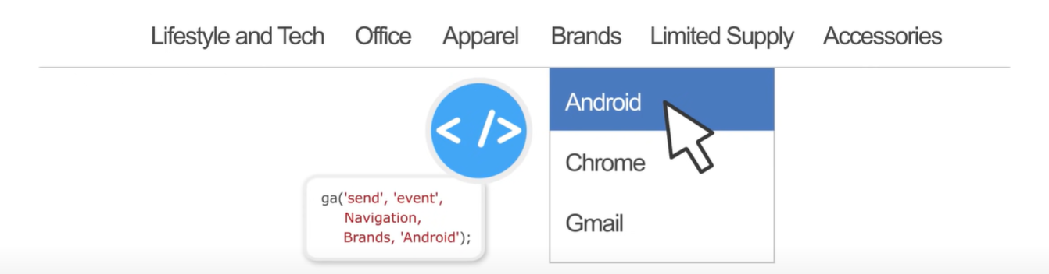

1. **Track Events:**
   * When the user interacts with the tracked element, the event data is sent to Google Analytics.
   * Events are recorded in the Events report under Behavior.
2. **Event Reports:**
   * **Total Events:** Count of all interactions.
   * **Unique Events:** Count of users triggering the event.
   * **Event Reports:** Located under Behavior > Events > Top Events.
   * Reports can be sorted by Category, Action, or Label for detailed analysis.

Example Report:

* + **Category:** “Navigation”
  + **Action:** “Brands”
  + **Label:** “Android”

1. **Use Cases:**
   * **Navigation Tracking:** Track clicks on navigation links.
   * **Outbound Link Tracking:** Monitor clicks on links leading away from your site.
   * **Custom Interactions:** Track specific interactions like downloads, video plays, or form submissions.
2. **Practical Application:**
   * Understand user interactions with specific elements on your site.
   * Optimize user experience by analysing event data.

**Example Implementation:**

To track a link, click, use:

JavaScript

ga('send', 'event', 'Outbound Links', 'Live Chat', 'Home');

This setup tracks how often users click the live chat button from the home page.

**Conclusion:** Event Tracking provides detailed insights into how users interact with various elements on your website, helping you refine and improve user engagement and overall site performance.

# Advance Analysis Tools & Techniques

## Segment data for insight

**Segmentation Overview:**

* **Purpose:** View subsets of data within reports.
* **Types:**
  + **User Segments:** Span multiple sessions, up to 90 days. Example: specific age range, gender, or date range.
  + **Session Segments:** Confined to user behavior within a single session. Example: sessions with goal completions or specific revenue.

**Benefits of Segmentation:**

* Compare different user behaviors, such as purchasers vs. non-purchasers.
* Analyze traffic sources, e.g., paid search vs. email campaigns.
* Segments can use dimensions, metrics, session dates, and user action sequences.

**Applying Segments:**

* **All Users Segment:** Automatically applied in reports.
* **Adding Segments:** Click "Add Segment" to open the segment builder.

**Types of Segments:**

* **Default Segments:** Pre-built segments in Google Analytics, found under the "System" section.
* **Custom Segments:** Created by users, shown under “Custom.”

**Using Default Segments:**

* **Selection:** Click the System section and choose the desired segment (e.g., Tablet traffic).
* **Comparison:** Segments are applied across all reports until removed.
* **Managing Segments:** Remove segments by clicking the down arrow and selecting “Remove.”
* **Multiple Segments:** Compare up to four segments simultaneously.
* **Actions Menu:** Options to copy or build an audience for remarketing.

**Creating Custom Segments:**

* **Process:** Click “Create New Segment.”
* **Customization:** Segment by demographics, technology, behavior, session dates, traffic sources, and ecommerce.
* **Advanced Segments:** Match dimensions and metrics to specific values, or create sequences of user interactions.
* **Sharing Segments:** Import or share segments via the Solutions Gallery.

**Important Notes:**

* Segments are applied after sampling, meaning sampled data will reflect in segments.
* Use segments to isolate data subsets and identify opportunities for website performance improvement.

**Summary**

Segmentation in Google Analytics allows for detailed analysis of user behavior by creating subsets of data. Users can create both default and custom segments to compare different groups and behaviors, leading to insights that can improve website performance. Segments can be shared and imported for collaborative analysis.

# Advanced Marketing Tools

## Introduction to remarketing

**Remarketing** is a strategy to target ad content to users who have already visited your website but didn’t complete a purchase. It aims to bring users back to your site and encourage conversions.

### Enabling Remarketing in Google Analytics

1. **Enable Advertising Features:**
   * Go to Admin > Tracking Info > Data Collection.
   * Set Remarketing and Advertising Reporting Features to "on."
2. **Link Accounts:**
   * Link your Google Ads or Display & Video 360 account to Google Analytics.

### Creating Remarketing Audiences

* **Definition:**
  + Audiences are groups of users based on browser cookies from those who visited a site with Google Analytics and remarketing tracking code enabled.
* **Steps to Create an Audience:**
  + Go to Admin > Audience Definitions > Audiences.
  + Click “New Audience.”
  + Select the view and account, then click “Next Step.”
  + Choose from preconfigured audience definitions or create a custom audience.

### Membership Duration

* You can set the membership duration for your audience from 1 to 540 days, determining how long users are eligible to see remarketing ads.

### Using Segments

* You can import a segment to create an audience or define a new audience from scratch.
* Use conditions to target specific user actions, like viewing particular product pages.

### Audience Lists in Ad Campaigns

* Audience lists will populate in the linked Google Ads or Google Marketing Platform accounts.
* Audiences that meet requirements for Search remarketing are eligible for both Search and Display remarketing.
* Note: Audiences including demographic dimensions like “Age, Gender, Interests” from the Google Display Network are not eligible for Search remarketing.

### Key Points

* **Remarketing is powerful** for re-engaging users who didn't complete conversions.
* **Audience creation** is flexible, allowing for preconfigured or custom segments.
* **Effective targeting** increases the likelihood of conversions by focusing on users already familiar with your site.

### Conclusion

Remarketing helps re-engage visitors, boosting conversion rates by targeting tailored ads based on user behavior and interactions on your website.

## Better targeting with Dynamic Remarketing

**Dynamic Remarketing** enables you to target ads more precisely by leveraging user interactions on your site, such as viewed content or products, purchase histories, and demographics.

### Steps to Set Up Dynamic Remarketing

1. **Link Accounts:**
   * Link your Google Ads and Analytics accounts.
   * For retail businesses, also link your Google Ads account to your Google Merchant Center.
2. **Enable Advertising Features:**
   * Enable Advertising features in Google Analytics.
3. **Setup Process:**
   * **Find Vertical Attributes:** Identify the vertical attributes for your industry (e.g., Retail).
   * **Create Custom Dimensions:** Use vertical attributes as names for Custom Dimensions in Analytics.
   * **Update Website Tags:** Add tracking code to your website to capture product IDs, page types, and total values.
4. **Create Remarketing Audiences:**
   * Define audiences based on user interactions (e.g., viewed homepage, search results, product details, abandoned cart, or previous conversions).
   * Use segments from Custom Dimensions or import preconfigured Remarketing Audiences.
5. **Create Dynamic Attributes:**
   * Navigate to Admin > Audience Definitions > Dynamic Attributes.
   * Click "New Attribute," select your Business Type (e.g., Retail), and choose the relevant Analytics view and Google Ads account.
   * Save the Dynamic Attributes.
6. **Create Dynamic Remarketing Campaigns:**
   * Use Google Ads to create campaigns targeting users based on their previous site interactions.

### Example Use Case

For the **Google Merchandise Store**:

* Track product IDs viewed, pages visited, and total product value.
* Create Custom Dimensions with vertical attributes.
* Implement tracking code on product pages.
* Define audiences (e.g., users who viewed product pages or abandoned carts).
* Create Dynamic Attributes and link to Google Ads.
* Launch dynamic remarketing campaigns to target these specific user groups.

### Key Points

* **Dynamic Remarketing** uses detailed user data to target ads more effectively.
* **Custom Dimensions and Dynamic Attributes** are essential for capturing and utilizing user interaction data.
* **Campaigns** can re-engage users based on their previous behavior, increasing the chances of conversions.